‘Mechanical Behavior and Strength of Engineering Materials’ Report

Student No. C240424 Name Yousef Ibrahim Gomaa Mahmoud Mabrouk

1. Which process could be used to form each of the following joints?



1. _Soldering (Liquid Process)_ (b) _ Diffusion Welding (DFW)_



1. _Explosive Welding (EXW)__ (d) _Friction Stir Welding_(FSW)

__(Solid State Process) _ _(Solid State Process) _



1. _Electron Beam Welding (EBW) (f) _Resistance Spot Welding (RSW)_

_(Fusion Welding) _ __(Fusion Welding)

2. Consider the CCT of a steel and the corresponding micrographs shown below.

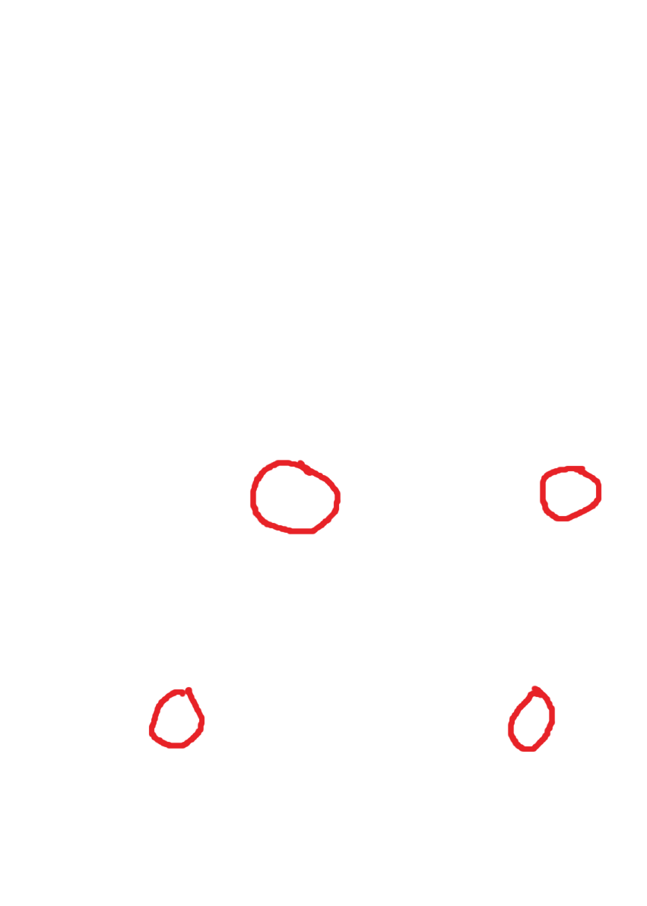

2.a In the microstructures provided, circle the number corresponding to the most likely cooling curve (identified as I –IV in the CCT)

[Answered on the previous illustration (2.)]

2.b Identify each of the microstructural constituents indicated in the microstructures.

(a) Pearlite FC(P) ______ (b) Martensite

(c) Intragranular Polygonal *Primary* Ferrite PF(I) (d) Acicular Ferrite (AF)

(e) Grain-boundary Ferrite PF(G)

2.c Consider the first microstructural image shown above. Approximately what percentage of phase (a) is present ?

* The percentage of α phase (Ferrite) is 67%

2.d What is the t8/5 for the curve labelled II ?

* The t8/5 cooling time between 800°C and 500°C according to the curve = time at 500°C – time at 800°C = 6-0 ≈ 6 seconds.
  + (The curve did not start at 800°C, however it did intersect 500°C at 6 seconds)

2.e What are the expected microstructural constituents and associated phase fractions for the curve labelled II ?

* 3% F (Ferrite) (α)
* 97% B (Bainite) (primarily consists of austenite, so γ)
* 0% M, P
* 100% total

3. Consider GTAW, GMAW, and SAW. For each process state concisely:

3.a What the acronym in the name stands for

(GTAW) Gas Tungsten Arc Welding

(GMAW) Gas Metal Arc Welding

(SAW) Submerged Arc Welding_

3.b How filler metal added, the relationship of filler metal to the electric circuit and typical polarity for steel welding.

(GTAW)

1. The filler metal is added either manually by an expert welder or automatically by a machine using external metal rods. The filler material can either be the same as the base material used (homogenous) or different (heterogenous). Sometimes, no filler metal is needed and instead the base material is welded together. (autogenous)
2. The filler metal used is not part of the electric circuit, as the tungsten (used due to its high melting point) electrode is non-consumable and produces the arc but does melt or act as the filler material. Instead, the filler metal is introduced manually via external metal rods that are either pre-heated by a secondary power supply (hot wire) or not (cold wire) and is melted by the arc.
3. GTAW runs at Constant Current (CC), which maintains stable arc strength, and the typical polarity of the electrode is negative (EN). Sometimes, GTAW runs on Alternating Current (AC) which is generally used to break up the oxide layer on aluminum)

(GMAW)

1. The filler metal (typically a solid or a tubular wire with flux/metal core in some sub-techniques) is automatically fed as it acts as both a consumable electrode and filler material which melts when heated up, falls in the form of droplets (depends on amount of current and voltage used; globular, streaming, projected or short circuit metal transfer) that joins the weld.
2. It forms a crucial part of the electrical circuit by carrying charges from the contact tip. During the welding process, the electrode wire melts and deposits molten metal into the weld pool.
3. GMAW runs at Constant Voltage (CV), which maintains stable arc length, and the typical polarity of the electrode is positive (EP).

(SAW)

1. Similar to GMAW, the filler metal is supplied automatically and acts as both a consumable electrode and filler material in the shape of a wire or a strip that melts into the weld pool.
2. It is part of the electric circuit, as the filler metal itself essentially creates the arc and melts in the process. In this process, the arc is produced underneath layers of conductive flux.
3. SAW runs at AC on a square waveform, with the typical polarity of electrode being positive (EP). In addition, it can run at CC at high currents or CV at medium to low currents.

3.c How the molten metal is protected from the atmosphere.

(GTAW)

* It is protected by inert shielding gases that flow out from the torch nozzle, such as argon or helium or mixtures of the two. (Referred to as TIG, Tungsten Inert Gas)
  + The inert gases surround the arc and molten metal, which ensures that the metal does not react with oxygen, nitrogen, hydrogen and other gases.
* In addition, gas lenses are generally applied to reduce turbulence.

(GMAW)

* Similar to GTAW, the molten metal is protected by shielding gases, which are delivered through the welding gun nozzle. The typical gases used are pure argon and helium. (Known as MIG, Metal Inert Gas) Other gases are used as well, such as mixtures of argon and oxygen, argon and carbon dioxide, and pure carbon dioxide. (Known as MAG, Metal Active Gas)

(SAW)

* Unlike GTAW and GMAW, the molten metal is protected by thick layers of flux (either fused or agglomerated) that becomes slag that protects the weld pool when melted, which is cooled then removed later on to reveal the weld underneath.
* The properties of the substances used in it controls oxygen and deoxidants. In addition, the fluxes provide a lot of flexibility for adding alloying components to the molten metal.